**Image and Video Editor**

# **Project description**

* It is an advanced image and video editor that has many features as
* Convert RGB images/videos to grayscale
* Convert grayscale images/videos to RGB
* Enhancement of image/video by blurring, sharpening, removing noise
* Cut and paste user-specified region in an image
* Resize images/videos
* Change images/videos background
* Add text/date and time to images/videos
* Draw some geometric figures according to user’s mouse hits on image/video
* View the color degree of any mouse hit on any spot of specified image in a new standalone image with its RGB values (web frontend developers interested in)
* Using trackbars to generate and edit images
* Detect any object in image by color and having it in a new image
* Make a pencil draw images from specified images (canny edge detection)
* Blend image/video horizontally and vertically
* Draw contours to image/video

# **Implementation Plan**

# **Team member roles**

# **Team member roles**

# 

# 

# **Image samples**

* Sample 1 : Detect any object in image by color and having it in a new image (the sample is just without a GUI)

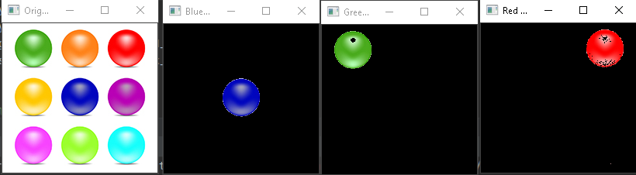

* Sample 2 : cut and paste object in the same image
* The bottom right ball is cut and pasted at the left top according to user decision

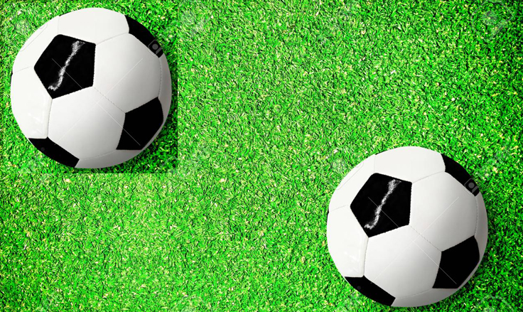

* Sample 3 : blend two images in one image

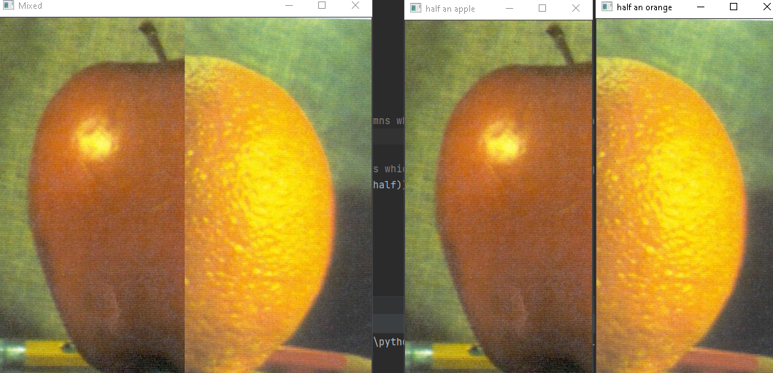

* Sample 4 : detect the color of a specific spot on image by user’s click

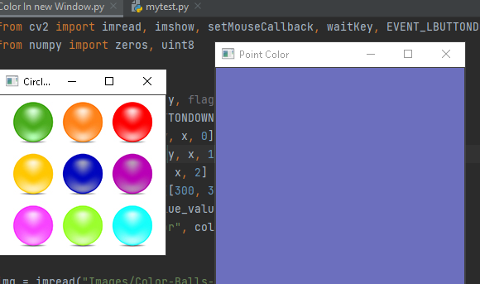

* Sample 5 : using trackbars in specifying colors

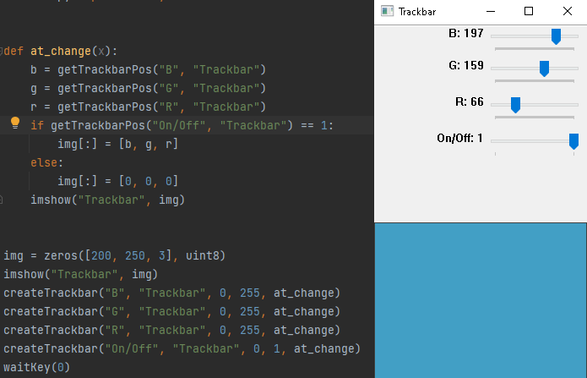

* Sample 6 : pencil-like drawing

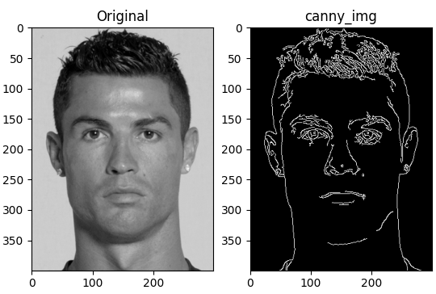

# **References**

# 

# 